Supplementary materials
Table S1 The DNA sample collection that have been used for SNP genotyping in this study, including the sample sizes, sample sources, sampling year and origin.
Country | Sample size | Sample sources | Sampling year
Sweden | 85 | The southern and northern populations are from blood, of which 21 individuals also have feather samples | 1997-2010
Norway | 13 | Extracted DNA from Blood | 2006
Denmark | 23 | Extracted DNA from Blood | 2005
Finland | 13 | Extracted DNA from Blood | 2003
Portugal | 40 | Feather | 2009-2010
Italy | 44 | 25 from feather sample, 19 from blood | 2012-2013
Bulgaria | 40 | Extracted DNA from Blood | 2010
Zambia | 15 | Blood | 2012
Cameron | 27 | Extracted DNA from Blood | 2014
Tanzania | 4 | Feather | 2002
South Africa | 8 | Feather | 2002
Ivory Coast | 12 | Feather | 1999
Kenya | 3 | Feather | 2000

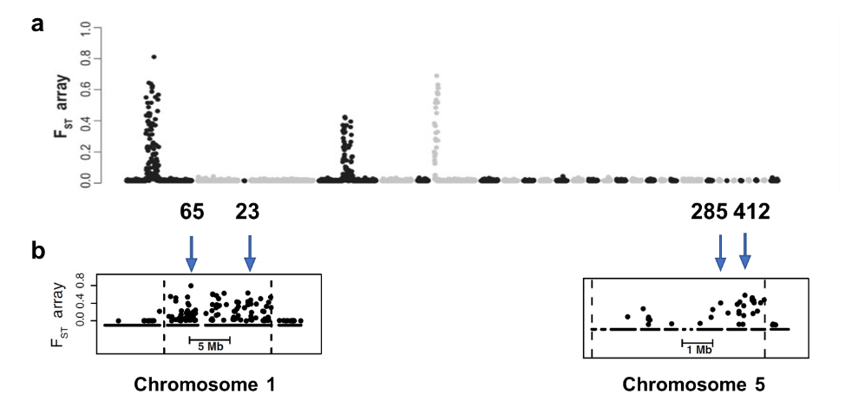
Fig. S1 F_{ST}-array results illustrating the genetic differentiation of ~4000 SNPs throughout the genome of willow warblers (Lundberg et al., 2017). a. High F_{ST} SNPs are restricted on certain blocks on chromosome 1, 3 and 5, while the other regions are with very low F_{ST} in general. b. SNP-array results within the highly differentiated blocks on chromosome 1 and 5, with arrows pointing out the positions of the SNPs selected for genotyping by qPCR.

Table S2. The sequences of primers and probes for the four selected SNPs on chromosome 1 and 5. The fluorophores VIC and FAM were used to differentiate the probe pairs for each SNP. The lengths of the amplified regions were between 95 and 144 bp. The target SNPs are indicated in bold.
Chromosome | SNP names |  | Base sequences | Region length
Chr_1 | 23 | Forward primer | TGAAACAGAATTTTGCAGTACTTCTACCT | 112
Chr_1 | 23 | Reverse primer | GTGCTTTCTAGTATATGGAAAAAAGAGGGA | 112
Chr_1 | 23 | VIC probe (North) | ATTGAAATCAAGAATTCAG | 112
Chr_1 | 23 | FAM probe (South) | ATTGAAATCAATAATTCAG | 112
Chr_1 | 65 | Forward primer | ACAACAACATGTAAAGCAGGAACCT | 96
Chr_1 | 65 | Reverse primer | ACCTGTTGTTAAAGGTTATGTCAATTCCT | 96
Chr_1 | 65 | VIC probe (North) | ACTAAATAACACTAAAATTTT | 96
Chr_1 | 65 | FAM probe (South) | ACTAAATAACACTAACATTTT | 96
Chr_5 | 412 | Forward primer | CATCTGGGCTCCACTTGCT | 144
Chr_5 | 412 | Reverse primer | TGTTGCCTAAATCCTGGGTTTCC | 144
Chr_5 | 412 | VIC probe (North) | TGCCCGGATTTTT | 144
Chr_5 | 412 | FAM probe (South) | TGCCCAGATTTTT | 144
Chr_5 | 285 | Forward primer | CACATTTATTAGTATTATGCCCCCAGGTA | 95
Chr_5 | 285 | Reverse primer | TATTGATTTAACAACACAGAATGCATGTGA | 95
Chr_5 | 285 | VIC probe (North) | CTGCATATAATCTTACCTTTC | 95
Chr_5 | 285 | FAM probe (South) | TGCATATAATCTTGCCTTTC | 95

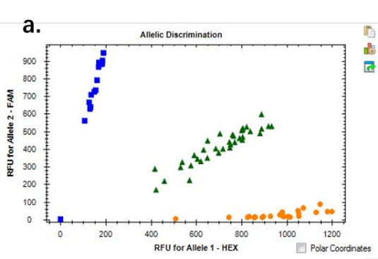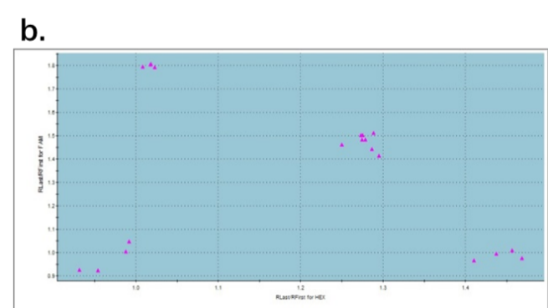
Fig. S2 Sample dual scatterplot of SNP genotyping result on a. BIO-RAD CFX Maestro™ software (for SNP 412); b. on MxPro – Mx3005P software (for SNP 285). The dots represent the fluorescence intensity for each sample. The dots with fluorescence detection mainly in the HEX channel are pure southern type; the dots with fluorescence detection mainly in the FAM channel are pure northern type; the dots with fluorescence detection in both FAM and HEX channels (sitting in the middle of each plot) are heterozygotes for the tested SNP.

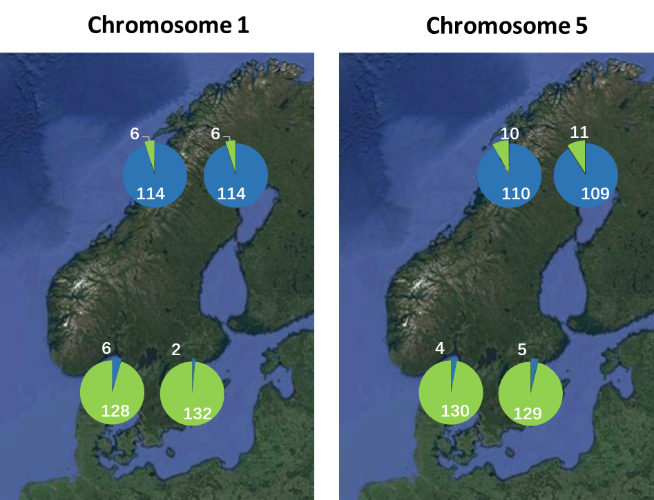
Fig. S3 Allele frequencies of the four selected SNPs on chromosome 1 and 5 in northern (upper pie charts) and southern populations (lower pie charts) in Scandinavia. For chromosome 1, the left pie charts are the allele frequencies of SNP 23 and the right ones are of SNP 65. For chromosome 5, the left pie charts are the allele frequencies of SNP 285 and the right ones are of SNP 412.

Table S3 Comparison between SNP genotype results from this study and the whole-block genotype results from Lundberg et al. (2017) for 97 individual willow warblers included in both data sets. Each of the two blocks contained two of the selected SNPs, respectively. The genotypes for both SNPs and the whole-blocks were southern homozygous, northern homozygous or heterozygous. We counted how many matches there were between the two genotype methods, and calculated the consistency ratio to verify the reliability of the selected SNPs to represent the whole blocks.
SNP | chr_1 |  | chr_5
SNP | 23 | 65 | 285 | 412
counts | 93/97 | 96/97 | 95/97 | 95/97
consistency ratio | 95.9% | 99.0% | 97.9% | 97.9%

Table S4 SNP genotyping results from sites in Scandinavia. Sites with latitude < 60° are regarded as southern population. Sites with latitude > 65° are regarded as northern population. We randomly selected 67 samples from the southern population and 60 samples from the northern population and did genotyping with all four SNP assays.
Sample name | Site name | Latitude | Longitude | SNP genotype
 |  |  |  | 23 | 65 | 285 | 412
01Q/01 | Gräsmarö | 58.28 | 16.98 | H | H | S | S
05B/08 | Kasted_Mose | 56.17 | 10.05 | H | S | S | S
05B/12 | Kasted_Mose | 56.17 | 10.05 | H | S | S | S
01A/13 | Stensoffa | 55.70 | 13.46 | H | S | S | S
97E/02 | Tåkern | 58.32 | 14.82 | S | S | H | H
03K/06 | Gräsmarö | 58.28 | 16.98 | S | S | H | H
08A/18 | Stensoffa | 55.70 | 13.46 | S | S | H | S
05C/02 | Gadevang_Mose | 55.83 | 12.47 | S | S | S | H
08B/06 | Stensoffa | 55.70 | 13.46 | S | S | S | H
03K/01 | Gräsmarö | 58.28 | 16.98 | S | S | S | S
97A/09 | Haganäs | 56.25 | 14.67 | S | S | S | S
08A/04 | Stensoffa | 55.70 | 13.46 | S | S | S | S
03A/08 | Stensoffa | 55.70 | 13.46 | S | S | S | S
05B/06 | Kasted_Mose | 56.17 | 10.05 | S | S | S | S
05C/01 | Gadevang_Mose | 55.83 | 12.47 | S | S | S | S
05C/08 | Gadevang_Mose | 55.83 | 12.47 | S | S | S | S
03A/06 | Stensoffa | 55.70 | 13.46 | S | S | S | S
01A/12 | Stensoffa | 55.70 | 13.46 | S | S | S | S
96A/05 | Stensoffa | 55.70 | 13.46 | S | S | S | S
97E/04 | Tåkern | 58.32 | 14.82 | S | S | S | S
97A/08 | Haganäs | 56.25 | 14.67 | S | S | S | S
01A/02 | Stensoffa | 55.70 | 13.46 | S | S | S | S
02A/08 | Stensoffa | 55.70 | 13.46 | S | S | S | S
03K/02 | Gräsmarö | 58.28 | 16.98 | S | S | S | S
08B/05 | Stensoffa | 55.70 | 13.46 | S | S | S | S
08XA/07 | Stensoffa | 55.70 | 13.46 | S | S | S | S
10A/07 | Stensoffa | 55.70 | 13.46 | S | S | S | S
97A/11 | Haganäs | 56.25 | 14.67 | S | S | S | S
97E/05 | Tåkern | 58.32 | 14.82 | S | S | S | S
97E/10 | Tåkern | 58.32 | 14.82 | S | S | S | S
97E/09 | Tåkern | 58.32 | 14.82 | S | S | S | S
01Q/04 | Gräsmarö | 58.28 | 16.98 | S | S | S | S
96A/15 | Stensoffa | 55.70 | 13.46 | S | S | S | S
02A/02 | Stensoffa | 55.70 | 13.46 | S | S | S | S
02A/09 | Stensoffa | 55.70 | 13.46 | S | S | S | S
97A/12 | Haganäs | 56.25 | 14.67 | S | S | S | S
05B/01 | Kasted_Mose | 56.17 | 10.05 | S | S | S | S
05B/02 | Kasted_Mose | 56.17 | 10.05 | S | S | S | S
05B/03 | Kasted_Mose | 56.17 | 10.05 | S | S | S | S
05B/04 | Kasted_Mose | 56.17 | 10.05 | S | S | S | S
05B/05 | Kasted_Mose | 56.17 | 10.05 | S | S | S | S
05B/07 | Kasted_Mose | 56.17 | 10.05 | S | S | S | S
05B/09 | Kasted_Mose | 56.17 | 10.05 | S | S | S | S
05B/10 | Kasted_Mose | 56.17 | 10.05 | S | S | S | S
05B/11 | Kasted_Mose | 56.17 | 10.05 | S | S | S | S
05C/03 | Gadevang_Mose | 55.83 | 12.47 | S | S | S | S
05C/04 | Gadevang_Mose | 55.83 | 12.47 | S | S | S | S
05C/05 | Gadevang_Mose | 55.83 | 12.47 | S | S | S | S
05C/06 | Gadevang_Mose | 55.83 | 12.47 | S | S | S | S
05C/07 | Gadevang_Mose | 55.83 | 12.47 | S | S | S | S
05C/09 | Gadevang_Mose | 55.83 | 12.47 | S | S | S | S
05C/10 | Gadevang_Mose | 55.83 | 12.47 | S | S | S | S
05C/11 | Gadevang_Mose | 55.83 | 12.47 | S | S | S | S
08A/06 | Stensoffa | 55.70 | 13.46 | S | S | S | S
08B/08 | Stensoffa | 55.70 | 13.46 | S | S | S | S
02A/03 | Stensoffa | 55.70 | 13.46 | S | S | S | S
02A/11 | Stensoffa | 55.70 | 13.46 | S | S | S | S
02A/13 | Stensoffa | 55.70 | 13.46 | S | S | S | S
08A/05 | Stensoffa | 55.70 | 13.46 | S | S | S | S
08A/13 | Stensoffa | 55.70 | 13.46 | S | S | S | S
96B/08 | Kvismaren | 59.17 | 15.42 | S | S | S | S
96B/05 | Kvismaren | 59.17 | 15.42 | S | S | S | S
03J/06 | Smedstorp | 59.58 | 14.98 | S | S | S | S
03J/07 | Smedstorp | 59.58 | 14.98 | H | S | H | H
02F/09 | Smedstorp | 59.58 | 14.98 | S | H | S | S
03J/02 | Smedstorp | 59.58 | 14.98 | H | S | S | S
01P/02 | Stensoffa | 55.70 | 13.46 | S | S | S | S
06D/06 | Kjöllefjord | 70.94 | 27.42 | H | H | H | H
01J/09 | Krokvik | 67.95 | 20.02 | H | H | N | N
01J/05 | Krokvik | 67.95 | 20.02 | H | H | N | N
06D/04 | Kjöllefjord | 70.94 | 27.42 | H | H | N | N
06D/07 | Kjöllefjord | 70.94 | 27.42 | H | H | N | N
06D/05 | Kjöllefjord | 70.94 | 27.42 | H | H | N | N
96M/05 | Ammarnäs | 65.95 | 16.12 | N | N | H | H
01O/03 | Kallax | 65.53 | 22.13 | N | N | H | H
03I/03 | Lurio | 67.23 | 27.55 | N | N | H | H
06E/08 | Tana_Bru | 70.18 | 28.20 | N | N | H | H
01K/01 | Tornehamn | 68.43 | 18.58 | N | N | H | H
01M/03 | Kaisepakte | 68.28 | 19.32 | N | N | H | H
01N/07 | Altajärvi | 67.83 | 20.53 | N | N | H | H
03I/02 | Lurio | 67.23 | 27.55 | N | N | H | H
10K/07 | Ekorrsjö | 64.49 | 19.07 | N | N | H | H
96M/01 | Ammarnäs | 65.95 | 16.12 | N | N | N | H
97N/14 | Gällivare | 67.22 | 20.80 | N | N | N | N
01N/05 | Altajärvi | 67.83 | 20.53 | N | N | N | N
03H/01 | Ruka | 66.18 | 29.42 | N | N | N | N
03H/06 | Ruka | 66.18 | 29.42 | N | N | N | N
03I/01 | Lurio | 67.23 | 27.55 | N | N | N | N
03I/10 | Lurio | 67.23 | 27.55 | N | N | N | N
06D/03 | Kjöllefjord | 70.94 | 27.42 | N | N | N | N
01K/05 | Tornehamn | 68.43 | 18.58 | N | N | N | N
03H/04 | Ruka | 66.18 | 29.42 | N | N | N | N
03H/08 | Ruka | 66.18 | 29.42 | N | N | N | N
97L/06 | Piteå | 65.03 | 21.45 | N | N | N | N
03I/04 | Lurio | 67.23 | 27.55 | N | N | N | N
01M/08 | Kaisepakte | 68.28 | 19.32 | N | N | N | N
01L/19 | Stordalen | 68.33 | 19.10 | N | N | N | N
01L/20 | Stordalen | 68.33 | 19.10 | N | N | N | N
97N/04 | Gällivare | 67.22 | 20.80 | N | N | N | N
01J/07 | Krokvik | 67.95 | 20.02 | N | N | N | N
01K/08 | Tornehamn | 68.43 | 18.58 | N | N | N | N
01N/08 | Altajärvi | 67.83 | 20.53 | N | N | N | N
97M/03 | Kukkola | 65.96 | 24.03 | N | N | N | N
97N/03 | Gällivare | 67.22 | 20.80 | N | N | N | N
01L/14 | Stordalen | 68.33 | 19.10 | N | N | N | N
01J/04 | Krokvik | 67.95 | 20.02 | N | N | N | N
01K/10 | Tornehamn | 68.43 | 18.58 | N | N | N | N
01O/01 | Kallax | 65.53 | 22.13 | N | N | N | N
03H/09 | Ruka | 66.18 | 29.42 | N | N | N | N
03I/06 | Lurio | 67.23 | 27.55 | N | N | N | N
03I/07 | Lurio | 67.23 | 27.55 | N | N | N | N
06D/02 | Kjöllefjord | 70.94 | 27.42 | N | N | N | N
06D/10 | Kjöllefjord | 70.94 | 27.42 | N | N | N | N
06E/01 | Tana_Bru | 70.18 | 28.20 | N | N | N | N
06E/02 | Tana_Bru | 70.18 | 28.20 | N | N | N | N
06E/04 | Tana_Bru | 70.18 | 28.20 | N | N | N | N
06E/05 | Tana_Bru | 70.18 | 28.20 | N | N | N | N
06E/07 | Tana_Bru | 70.18 | 28.20 | N | N | N | N
97M/01 | Kukkola | 65.96 | 24.03 | N | N | N | N
97L/03 | Piteå | 65.03 | 21.45 | N | N | N | N
97M/07 | Kukkola | 65.96 | 24.03 | N | N | N | N
01O/08 | Kallax | 65.53 | 22.13 | N | N | N | N
10J/09 | Granö | 64.27 | 19.42 | N | N | N | N
10L/02 | Gunnarn | 65.00 | 17.71 | N | N | N | N
01N/12 | Altajärvi | 67.83 | 20.53 | N | N | N | N
01O/04 | Kallax | 65.53 | 22.13 | N | N | N | N
03H/10 | Ruka | 66.18 | 29.42 | N | N | N | N

Table S5 SNP genotyping results from southern Europe in autumn (August - October), the migration sites for willow warblers. SNP 65 and 285 were used to test all samples. When the genotype was HH, NS, SN, we used SNP 23 and 412 to cross-check the genotype result. Genotype NN, NH, HN were assigned to northern population, SS, HS, SH were assigned to southern population, HHHH was assigned to heterozygotes, NNSS and SSNN were assigned to F2, the rests were assigned as Undefined.
Sample name | Country | SNP genotypes |  |  |  | Assignment
Sample name | Country | 23 | 65 | 285 | 412 | Assignment
6G0646 | Italy |  | N | N |  | northern pop.
6G0653 | Italy |  | N | N |  | northern pop.
1A78028 | Italy | S | S | N | N | F2
6G0640 | Italy |  | N | H |  | northern pop.
6G0622 | Italy |  | H | N |  | northern pop.
6G0639 | Italy |  | H | N |  | northern pop.
6G0603 | Italy |  | N | N |  | northern pop.
6G0606 | Italy |  | N | N |  | northern pop.
6G0607 | Italy |  | N | N |  | northern pop.
6G0619 | Italy |  | N | N |  | northern pop.
6G0644 | Italy |  | N | N |  | northern pop.
6G0616 | Italy |  | S | H |  | southern pop.
6G0636 | Italy |  | N | H |  | northern pop.
3A15807 | Italy |  | S | S |  | southern pop.
6G0623 | Italy |  | H | N |  | northern pop.
6G0615 | Italy |  | H | N |  | northern pop.
6G0656 | Italy |  | H | N |  | northern pop.
6G0612 | Italy |  | N | N |  | northern pop.
6G0618 | Italy |  | N | N |  | northern pop.
6G0654 | Italy |  | N | N |  | northern pop.
6G0655 | Italy | S | S | N | N | F2
1A78029 | Italy |  | S | H |  | southern pop.
6G0601 | Italy | H | H | H | H | heterozygote
6G0649 | Italy | H | H | H | H | heterozygote
6G0611 | Italy | H | H | H | S | Undefined
659 | Italy |  | N | N |  | northern pop.
621 | Italy |  | H | N |  | northern pop.
508 | Italy | S | S | N | H | Undefined
515 | Italy | H | H | H | H | heterozygote
658 | Italy | H | H | H | H | heterozygote
517 | Italy | H | H | H | H | heterozygote
625 | Italy |  | N | N |  | northern pop.
637 | Italy |  | N | N |  | northern pop.
657 | Italy |  | N | N |  | northern pop.
509 | Italy |  | S | S |  | southern pop.
502 | Italy |  | N | N |  | northern pop.
510 | Italy |  | N | N |  | northern pop.
511 | Italy |  | N | N |  | northern pop.
512 | Italy |  | N | N |  | northern pop.
634 | Italy |  | N | N |  | northern pop.
660 | Italy |  | N | N |  | northern pop.
503 | Italy |  | S | H |  | southern pop.
506 | Italy | H | H | H | H | heterozygote
504 | Italy |  | S | H |  | southern pop.
079807 | Portugal |  | S | S |  | southern pop.
089873 | Portugal |  | S | S |  | southern pop.
079874 | Portugal |  | S | S |  | southern pop.
079808 | Portugal |  | S | S |  | southern pop.
072387 | Portugal |  | S | S |  | southern pop.
072389 | Portugal |  | S | S |  | southern pop.
079810 | Portugal |  | S | S |  | southern pop.
079873 | Portugal |  | S | S |  | southern pop.
079809 | Portugal |  | S | S |  | southern pop.
072392 | Portugal |  | S | S |  | southern pop.
079871 | Portugal |  | S | S |  | southern pop.
089868 | Portugal |  | S | S |  | southern pop.
089869 | Portugal |  | S | S |  | southern pop.
079875 | Portugal | H | H | H | H | heterozygote
079872 | Portugal |  | S | S |  | southern pop.
079811 | Portugal |  | S | H |  | southern pop.
089875 | Portugal | H | H | H | H | heterozygote
089874 | Portugal |  | S | S |  | southern pop.
072390 | Portugal |  | S | S |  | southern pop.
072388 | Portugal |  | S | S |  | southern pop.
079765 | Portugal |  | H | S |  | southern pop.
079766 | Portugal |  | S | S |  | southern pop.
079767 | Portugal |  | S | S |  | southern pop.
079768 | Portugal |  | S | S |  | southern pop.
079769 | Portugal |  | S | S |  | southern pop.
079912 | Portugal |  | S | S |  | southern pop.
079913 | Portugal |  | S | S |  | southern pop.
079914 | Portugal |  | S | S |  | southern pop.
079915 | Portugal |  | S | S |  | southern pop.
079916 | Portugal |  | S | S |  | southern pop.
089840 | Portugal |  | S | S |  | southern pop.
089841 | Portugal |  | S | S |  | southern pop.
089842 | Portugal |  | S | S |  | southern pop.
089843 | Portugal |  | S | S |  | southern pop.
089844 | Portugal |  | S | H |  | southern pop.
089846 | Portugal |  | S | S |  | southern pop.
089847 | Portugal |  | S | S |  | southern pop.
089848 | Portugal |  | S | S |  | southern pop.
089849 | Portugal | S | S | N | N | F2
089850 | Portugal | S | S | N | N | F2
44 | Bulgaria |  | N | H |  | northern pop.
45 | Bulgaria |  | N | N |  | northern pop.
48 | Bulgaria |  | N | N |  | northern pop.
54 | Bulgaria |  | N | N |  | northern pop.
58 | Bulgaria |  | N | N |  | northern pop.
62 | Bulgaria |  | N | N |  | northern pop.
80 | Bulgaria |  | N | N |  | northern pop.
91 | Bulgaria |  | N | N |  | northern pop.
94 | Bulgaria |  | N | N |  | northern pop.
98 | Bulgaria |  | N | H |  | northern pop.
101 | Bulgaria |  | N | N |  | northern pop.
107 | Bulgaria |  | N | N |  | northern pop.
145 | Bulgaria |  | N | N |  | northern pop.
146 | Bulgaria |  | N | N |  | northern pop.
148 | Bulgaria |  | N | N |  | northern pop.
150 | Bulgaria |  | S | H |  | southern pop.
151 | Bulgaria |  | N | N |  | northern pop.
165 | Bulgaria |  | N | N |  | northern pop.
173 | Bulgaria |  | N | N |  | northern pop.
188 | Bulgaria |  | N | N |  | northern pop.
209 | Bulgaria |  | N | N |  | northern pop.
212 | Bulgaria |  | N | N |  | northern pop.
213 | Bulgaria |  | N | N |  | northern pop.
214 | Bulgaria |  | N | N |  | northern pop.
219 | Bulgaria |  | N | N |  | northern pop.
222 | Bulgaria |  | N | N |  | northern pop.
226 | Bulgaria |  | N | N |  | northern pop.
234 | Bulgaria |  | N | N |  | northern pop.
243 | Bulgaria |  | N | N |  | northern pop.
244 | Bulgaria |  | N | N |  | northern pop.
248 | Bulgaria |  | N | N |  | northern pop.
251 | Bulgaria |  | N | N |  | northern pop.
254 | Bulgaria |  | N | N |  | northern pop.
257 | Bulgaria |  | N | N |  | northern pop.
262 | Bulgaria |  | N | N |  | northern pop.
264 | Bulgaria |  | N | N |  | northern pop.
271 | Bulgaria |  | N | N |  | northern pop.
268 | Bulgaria |  | N | N |  | northern pop.
275 | Bulgaria | N | N | S | H | Undefined
278 | Bulgaria |  | N | H |  | northern pop.

Table S4 SNP genotyping results from Africa in winter (November - April), the wintering sites for willow warblers (Ivory Coast and Cameron as western Africa, and Zambia, Kenya, Tanzania and South Africa as eastern Africa). SNP 65 and 285 were used to test all samples. Genotype NN, NH, HN were assigned to northern population, whereas SS, HS, SH were assigned to southern population.
Sample name | Country | SNP genotypes |  | Assignment
Sample name | Country | 65 | 285 | Assignment
Z69 | Zambia | N | N | northern pop.
Z74 | Zambia | N | H | northern pop.
Z60 | Zambia | N | N | northern pop.
Z65 | Zambia | N | N | northern pop.
Z72 | Zambia | N | N | northern pop.
Z73 | Zambia | N | N | northern pop.
Z61 | Zambia | N | N | northern pop.
Z62 | Zambia | N | N | northern pop.
Z63 | Zambia | N | N | northern pop.
Z64 | Zambia | N | N | northern pop.
Z67 | Zambia | N | N | northern pop.
Z68 | Zambia | N | N | northern pop.
Z71 | Zambia | H | N | northern pop.
Z75 | Zambia | N | N | northern pop.
Z76 | Zambia | N | N | northern pop.
K39204 | Kenya | N | N | northern pop.
K39205 | Kenya | N | N | northern pop.
8N 55600 | Kenya | N | N | northern pop.
446 | Tanzania | N | N | northern pop.
T33467 | Tanzania | N | N | northern pop.
T33468 | Tanzania | H | N | northern pop.
448 | Tanzania | N | N | northern pop.
AE28933 | South Africa | N | N | northern pop.
AE28932 | South Africa | N | H | northern pop.
AE28954 | South Africa | N | N | northern pop.
AF60012 | South Africa | N | N | northern pop.
W17819 | South Africa | N | N | northern pop.
W17824 | South Africa | N | H | northern pop.
W17825 | South Africa | N | N | northern pop.
W17826 | South Africa | N | N | northern pop.
BE7350 | Ivory Coast | S | S | southern pop.
BE7351 | Ivory Coast | S | S | southern pop.
BE7352 | Ivory Coast | S | S | southern pop.
BE7353 | Ivory Coast | N | N | southern pop.
BE7354 | Ivory Coast | S | S | southern pop.
BE7355 | Ivory Coast | S | S | southern pop.
BE7356 | Ivory Coast | S | S | southern pop.
BE7357 | Ivory Coast | S | H | southern pop.
BE7358 | Ivory Coast | S | S | southern pop.
BE7359 | Ivory Coast | S | S | southern pop.
BE7360 | Ivory Coast | S | S | southern pop.
BE7361 | Ivory Coast | S | H | southern pop.
405 | Cameron | S | S | southern pop.
411 | Cameron | S | S | southern pop.
412 | Cameron | H | S | southern pop.
420 | Cameron | S | S | southern pop.
425 | Cameron | S | S | southern pop.
426 | Cameron | S | H | southern pop.
427 | Cameron | H | S | southern pop.
429 | Cameron | H | S | southern pop.
432 | Cameron | S | H | southern pop.
438 | Cameron | S | S | southern pop.
439 | Cameron | S | S | southern pop.
442 | Cameron | S | H | southern pop.
443 | Cameron | S | S | southern pop.
444 | Cameron | S | H | southern pop.
448 | Cameron | S | S | southern pop.
449 | Cameron | S | S | southern pop.
452 | Cameron | S | H | southern pop.
456 | Cameron | S | S | southern pop.
466 | Cameron | S | S | southern pop.
468 | Cameron | S | H | southern pop.
491 | Cameron | S | S | southern pop.
494 | Cameron | H | S | southern pop.
501 | Cameron | S | H | southern pop.
502 | Cameron | S | S | southern pop.
505 | Cameron | S | S | southern pop.
509 | Cameron | S | S | southern pop.
518 | Cameron | S | S | southern pop.

